PROPOSAL

Open source software development technology

**Submitted To:** Sir Kashif

**Submitted By:**

998/Asma Bashir

1060/Sadia Khalid

1048/Anam Atiq

1071/ Hira Ali Kiani

1020/Ifrah Shaheen

BSSE F09 A



Clothing Store:

* Items that store includes are jewelry , cloths, shoes and cosmetics
* User accounts:

Users can create their account on “Her Designs” using the signing up option provided. This account could then be used to purchase from the website. This would have to be done only the first time that the user visits.

* Sign In:

Users would have to sign in to their respective accounts by providing their username and passwords to purchase.

* Cart:

A session is maintained for every user so all their purchases are managed using an online cart.

* Guest account

User can visit website and can browse different categories and respective items placed at there and for that user don’t required to provide any user name and passwords.

* Database retrieval:

All the order, complaints and products information is stored and retrieved from database dynamically.

* Complaint registration:

Only Registered Users have given an option to register their complaints so they can suggest and notify changes they want and detail information they require, along with any complaints regarding their order.

* Contact us

Users can contact us using the Contact Us information provided that is our email ids, phone numbers and franchise details.

* Categorization:

All the products are categorized according to their type for easy access of our website. So the user can easily jump in to the products of their interest.

* + Gallery of new arrivals:



A separate gallery is maintained to notify our visitors about all the new arrivals using the timestamp information saved in database.

* + Shoes Gallery:

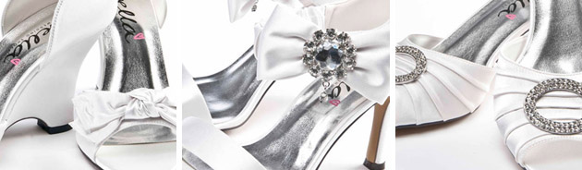

Gallery of shoes provides all the listings and images of the shoes available for purchase.

* + Gallery of the jewelry:



It contains jewelry items and their details with sub categorization according to rings, necklaces, bracelets, ear ornaments, nose pins and studs.

* + Gallery of the clothes:



It provides a listing of the clothe line. Whereas user can jump into a particular sub category of type of clothes such as jeans, t shirts, kurtas, tops, shalwar kameez, veils, tunics, joggings, scaarfs, corsets.

* Bill details:

Total bill and order details are saved and displayed to the user when required and before and after payment.

* Order removal:

Customers can remove their order any time before shipment.

* Edit order:

Orders can be edited that is items can be edited and deleted any time before shipment.

* Order tracing:

Customers can trace their orders using a reference id provided to them at the time of ordering that is check the time before arrival of their order or delete their order in case it’s not already being shipped.

* Slide shows:

Slide shows are used to display some products. These are the slide shows displaying hot selling items, latest sales etc along with their prices.